Lesson Learned Real Snares

On small animal like rabbits, muskrats, and squirrels without a doubt the 110 conibear is the best trap to own. When you get into larger animals snares can be just as effective and sometimes better then traps.

Over the winter I was making a new snaring video wind chill at times was 50 below and the snares keep working taking beautiful thick prime Jan coyotes. With snow and wind it would have been very hard to keep traps working. This example shows snares are more effective.
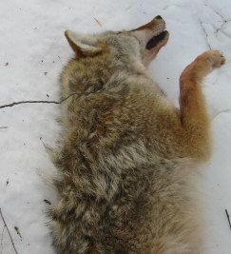Snares are the way to go in the winter.

After years talking with several people about homemade wire snares I decide to try 22 ga galvanized wire and 24 ga copper wire. Again people have told me that the 22 ga galvanized wire was the wire to have for snares. So maybe I am wrong and really gave them an honest try. I place 4 snares out 2 steel and 2 copper. Using my 4 snares per 1 animal average.

Finding good trails for the little cottontail rabbits I was confident these homemade snares would work. The next morning I was checking and 2 of the 4 snares had made catches but no rabbits. Did coyotes steal them? Nope no tracks in the snow! What did I find when I check them? Both snares failed! I found a tore up area broken wire and no rabbit. Every time I try the single strand wire I find it broken or limited success (on squirrels).
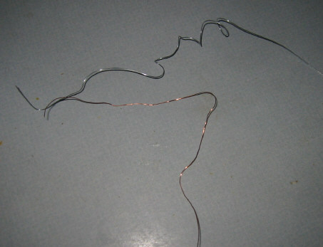

So why would anyone bet their life on these snares? I have asked this question many times if homemade wire snares work so good why do trappers use real self locking snares? Really why paid for snares if you can make up tons using single strand wire snares? Because they are not reliable. When you are trapping for food you want ever single advantage you can get. Trapping and snaring is a percentage game. You place snares or traps out in numbers planning on making catches. When you first start until you learn to read the trails and animal sign you will have limited success. The better you get the more you catch. But what is the most important thing to remember? Your scent? Nope, your location? Good choice but nope. How you place your snare? Another good choice but nope? Ok here it is? Good equipment equals success? Granted good equipment is the first step then you still have a learning curve but as you become successful you will bring more food home because you have good equipment that will hold the intended animal.

I then used real 1/16 small game snares made out of galvanized aircraft cable, that is self locking.
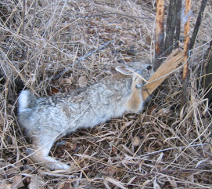

I know big surprise but guess what? No more broken wire and every single rabbit that was caught in the snares, was waiting for me when I came back.

The first night with real snares I had another first. I caught a skunk going into a rabbit den. I knew skunks were eggs eater there has been many a duck study done proving skunks kill or run off the hen duck and eat the eggs. So was the skunk going in to try and kill the rabbits or looking for a den already build? Next day skunk number 2 was waiting. It appears the skunk killed all the rabbits or scared them out of the area. Glad to be rid of them nothing worst on homestead then skunks spraying the dog and eating all the eggs from the chickens.
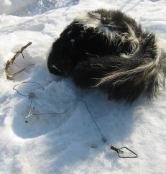

Lesson learned why play at it use real snares for real results. The other problem was after using the single strand 22 ga snare there was 2 rabbits that would not enter a good snare. Even rabbit can learn to shy away from snares. Why were they shying away. Well the big obvious answer is they were caught in the single strand 22 ga galvanized wire broke free and now knew to stay away from them. I have said this before there are not smart animals there are educated because of mistakes. Those 2 rabbits had escape the snares and now would stop dead in the trail on any snare they saw and detour around it.

